Public Administration and Constitutional Affairs Committee

Inquiry: the Scrutiny of International Treaties and other international agreements in the 21st century

Evidence from the Trade Justice Movement

David Lawrence
May 2021

- The Trade Justice Movement is a UK-wide network of sixty civil society organisations, with millions of individual members, calling for trade rules that work for people and planet. Our members include trade unions, NGOs, consumer groups and faith organisations. Together we are calling for trade justice, where the global trade system ensures sustainable outcomes for people and the planet.
- We have deep concerns about the UK’s existing scrutiny process for international treaties, particularly trade agreements. We engaged heavily with the Trade Bill and supported amendments on parliamentary scrutiny of trade agreements which had cross-party support, but were defeated. While we welcome concessions from ministers made at the Despatch Box, we believe there is still much that can be done to improve the level of scrutiny, and therefore this committee’s inquiry is important and timely.
- The UK’s departure from the European Union and its plans for new trade agreements has highlighted the democratic deficit in the scrutiny of trade deals. However, Brexit also provides an opportunity for reforming this process, as the UK adopts an independent trade policy for the first time in nearly 50 years. While the Trade Bill was a missed opportunity for reform, the Government should set out new legislation which ensures democratic oversight and transparency in trade negotiations. Ideally, this would form part of a wider, published strategy for post-Brexit trade policy.

The UK’s existing scrutiny processes

- The UK’s current model of scrutiny fails to provide businesses, the public and civil society organisations with transparency and predictability. This makes it difficult for organisations to know what the government’s plans are, and how the UK’s new trade policy might impact on the economy, jobs, regulation and social welfare.
- An absence of democratic oversight can lead to bad trade deals, as new FTAs are unlikely to have popular support; and without transparency, businesses and other organisations are less well prepared for regulatory and cross-border changes. When it comes to transparency and parliamentary scrutiny, the UK lags behind international counterparts, including many of our most important trading partners - notably the US, the EU and Japan (see Table 1).
Table 1 - the UK’s scrutiny processes compared to key partners

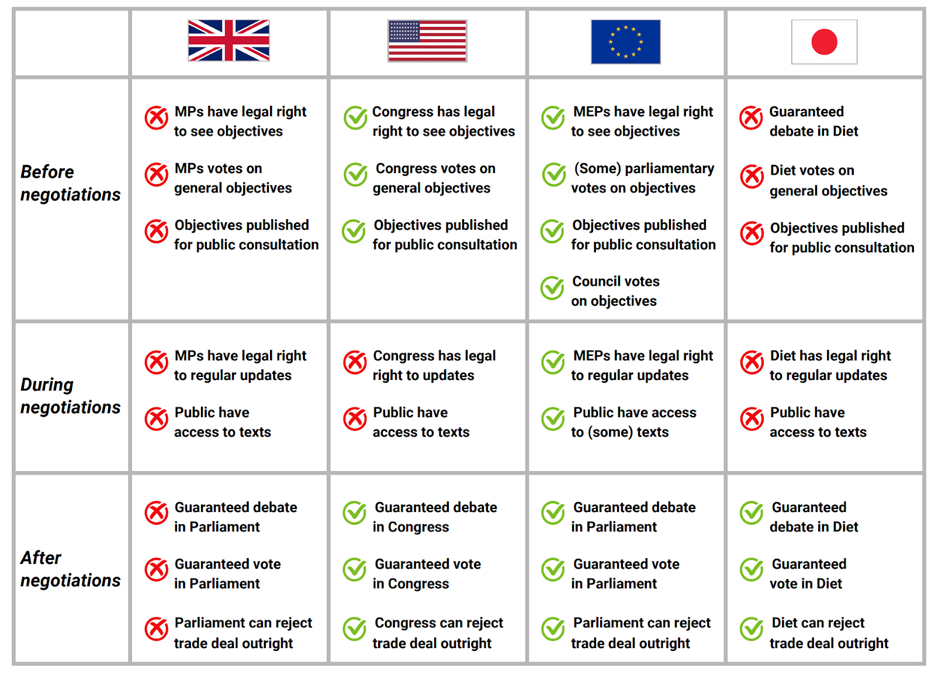

- Under the existing scrutiny system, set out in the Constitutional Reform and Governance (CRAG) Act (2010), MPs have very little say in the development of trade policy. Parliament is not involved in setting a mandate for trade agreements, is excluded from the negotiation process and there are no guaranteed votes or debates on new trade agreements. It is very difficult for MPs to secure a debate on a new deal.
- The constitutional theory behind the UK’s dualist system is that foreign policy - including the power to make international treaties - is the remit of the Executive, but the Executive cannot alter domestic legislation or the UK constitution without parliamentary consent. However the nature of modern trade agreements is that they affect huge swathes of public policy, including consumer and workers’ rights, environmental legislation, health standards and public services, often without the need for additional legislation. Trade agreements can have much more far-reaching domestic consequences than public bills and yet are not afforded anything like the same level of parliamentary scrutiny.
- Recent negotiations around Brexit, the proposed UK-US trade deal and the EU’s negotiations of TTIP and CETA have demonstrated that there is strong public and parliamentary interest in trade negotiations. Excluding Parliament and the public from the debate risks losing the democratic mandate to negotiate trade deals - as shown by public opposition towards TTIP and the proposed UK-US trade agreement.
Problems with the existing system of treaty scrutiny

- There are five main issues with existing treaty scrutiny processes:
(1) No involvement of Parliament in setting the mandate before negotiations. The Government has no obligation to present negotiating objectives to Parliament, and if they do, there is no vote before negotiations begin. This means that there is no formal process to ensure that the views of MPs and their constituents are taken into account in shaping trade deals. It means that Opposition parties have no formal way of challenging the Government’s mandate and negotiating priorities, despite their potential wide-reaching public policy implications.
(2) No requirements for transparency during negotiations. Parliament has no formal role during the negotiation of treaties. There are no guaranteed updates after negotiating rounds, and any reports are at the Government’s discretion. This makes it difficult for Parliament to scrutinise or challenge the Government’s actions, or raise constituents’ concerns about the progress of trade agreements. There are models of transparency in other institutions, such as the EU, which ensure that both the legislature and general public are kept informed about the progress of negotiations.
(3) No formal role for civil society, businesses or members of the public. External input relies on the Department for International Trade deciding to run public consultations or host stakeholder briefings. This is not a formally guaranteed process; for instance, in 2018 the Department for International Trade consulted on four new trade agreements, but decided against consulting on ‘rollover agreements’. There are also problems with how these consultations are run: since the civil service serves the government of the day, it does not have the same level of independence as parliamentary committees. There is a lack of clarity about how responses to government consultations are assessed, and there are no public hearings or recorded discussions. It is also unclear how the Department for International Trade decides which civil society voices to prioritise in its advisory groups; for example, there are many more DIT advisory groups for businesses than there are for trade unions or charities.
(4) No guarantee of debate or vote after a treaty is agreed. The CRAG system does not guarantee Parliament a debate or vote when a trade agreement is signed. Instead, these debates are either granted by the executive or must be sought through Opposition days, which are rare.
(5) Votes on new trade agreements are not meaningful. Where Parliament does get a vote on proposed trade deals, this vote is not very meaningful as the treaty is already signed and cannot be amended. The terms of the treaty are presented to Parliament as a ‘take it or leave it’ offer, which can lead to Hobson’s Choice facing individual MPs and Lords. It is not hard to imagine treaties which contain lots of controversial or undesirable provisions, but are on balance supported by MPs, and therefore receive approval in their entirety. Indeed, these exact concerns have been raised about the government’s recently agreed UK-EU Trade and Cooperation Agreement. CRAG votes also have limited value because the government can choose to bring a treaty back to Parliament after the 21 sitting day period. While Parliament could theoretically delay a treaty from being ratified indefinitely, in practice it will be difficult to secure a debate without government provision.
The Trade Bill concessions and their shortcomings

- During the passage of the Trade Bill, the Government made a number of verbal and written promises on treaty scrutiny, all of which fell short of legislative amendment, but nonetheless slightly strengthened the UK’s treaty scrutiny processes.
- First, a combination of parliamentary restructuring and commitments made in a 2019 Command Paper have given parliamentary committees a greater role in scrutinising trade deals. Namely, Commons’ International Trade Committee has a greater role and the Lords International Agreements Committee has been established. The two committees will have the power to see treaty texts before they are published and recommend deals for debate on the floor of the relevant chamber. They have been conducting inquiries into all of the UK’s new trade agreements (excluding rollovers), and civil society groups will have the opportunity to give evidence in inquiries.

- Second, in the 2019 Command Paper, and at the Despatch Box during Trade Bill debates, the government committed to publishing objectives before negotiations begin and providing a statement to the House of Commons. This allows for some debate, but no vote. It has not been used for rollover trade agreements, but only new agreements, and in some cases the objectives have been delayed - such as for the CPTPP (Trans-Pacific Partnership).
- Third, although CRAG processes do not require a debate after a deal is signed, trade minister Lord Grimstone recently said that he “cannot envisage” a new FTA proceeding to ratification without a debate first having taken place on it, should one be requested by a relevant committee.

- Fourth, the Government has committed to consult with devolved administrations and civil society. It has set up various stakeholder engagement groups in the Department for International Trade, though various concerns have been raised about the effectiveness of these groups, their membership, and the requirement for members to sign restrictive Confidentiality Agreements.
- Although these changes are welcome, they are very small changes, and the fundamentals of treaty scrutiny remain the same. The process is still governed by CRAG, which remains unamended, and there are no guaranteed debates or votes for MPs or Lords on trade agreements, both before and after deals are signed. All of the concessions above depend on goodwill from the Government. Furthermore, the processes rely very heavily on select committees, which will be responsible for negotiating a large number of trade agreements (including 40 rollover trade agreements, in addition to new deals). The length and depth of trade agreements means that this is a lot of work for committees which have a membership of 11 (the ITC) and 12 (the IAC).

A new model of treaty scrutiny

- Parliament should play a far greater role in the future in scrutinising treaties, and there should be mechanisms in place for civil society, businesses and the general public to be consulted on future trade agreements. The following proposals should be considered:
(1) Involvement before negotiations. Parliament should be able to debate and vote on proposals to enter into formal trade negotiations, and use this to set out and approve the Government’s negotiating mandate. This should be protected in legislation.
(2) Transparency during negotiations. The Government should have a policy of releasing key negotiating texts, after negotiating rounds, and to Parliament during negotiations. This will mean that the general public, Parliament, civil society and business groups are kept informed of the progress of negotiations and the expected future shape of trade agreements. There is precedent elsewhere for regularly releasing negotiation documents and providing updates to stakeholders on negotiation progress, such as in the EU. Similarly, the UK Parliament’s European Scrutiny Committee has regular access to EU documents and correspondence, which it can sift, scrutinise and refer for debate.
(3) A formal role for civil society and businesses, and full impact assessments. Impact assessments should be independent and cover not just economic impact but also environmental and social factors. For example, an impact assessment on a trade deal with the US should look at how the deal might affect the standard of food on British supermarket shelves, the welfare of animals, the environmental impact, the effect of regulatory cooperation on workers’ rights, and the effect of investment provisions on democracy and scrutiny. This will allow Parliament, civil society and the general public to be fully informed about the benefits and risks of a new trade agreement, and also inform the Government’s own cost-benefit analysis.
(4) Guaranteed debates and meaningful vote. There should be a process, set out in legislation, which goes beyond CRAG to ensure that both Houses are given adequate time to debate and vote on trade agreements before they are signed. The resolution approving a trade agreement should require approval from the House of Commons.
(5) Treaty withdrawal. There should be a regular review of trade agreements to ensure that they are beneficial to the economy, society and environment. Trade agreements should not imply indefinite or excessively long-term commitments that override Parliamentary sovereignty, but it should be within the power of Parliament to terminate agreements if it wishes. There should be processes in place so that MPs and Lords know how to raise concerns about trade agreements and provision for debates and votes in the Commons or both Houses that can lead to the termination of trade agreements.

Engaging businesses, civil society and the public

- There are various ways to involve stakeholders in negotiations, and some alternative models from other countries are discussed in answer to the next question. Broadly speaking, there are four main ways Parliament should engage stakeholders and members of the public:
(1) Full impact assessments. It should be a statutory part of trade policy that potential trade agreements receive full impact assessments, conducted independently, which cover economic, social and environmental factors. To this end, the impact assessments should be produced with opportunities for input and dialogue from relevant stakeholders. For example, if a trade agreement with Australia has the potential to impact Welsh sheep farmers, these groups must be consulted as part of the social aspect of the impact assessment. Similarly, assessing animal welfare should require engaging with animal welfare groups. Furthermore, the Government should ensure that the process for engaging with these independent impact assessments is straightforward, and that there is rigorous methodology for ensuring that all relevant voices are heard.
(2) Committee inquiries. It should be regular practice for the Commons International Trade Committee and the Lords International Agreements Scrutiny Committee, along with any other relevant committees, to conduct inquiries on new trade agreements.
(3) Local listening exercises. During TTIP negotiations, BritishAmerican Business and others organised TTIP ‘roadshows’ across the UK to promote TTIP to local communities, amidst public scepticism towards the deal. Although these roadshows had an obvious agenda behind them, the principle of reaching out to local communities and hearing their concerns is important. This would not only inform the negotiation objectives and subsequent content of trade deals, but would also mean that any final agreement is more likely to reflect a broad consensus from the wider population. As with any local outreach, it is important to ensure that there is good communication between central government and civil society - not just with local councils, but also local businesses, faith groups, trade unions, schools, local charities and civic action groups.
(4) A reformed and transparent model of DIT stakeholder engagement. DIT’s current model is somewhat chaotic, with multiple different kinds of stakeholder groups and channels, each of which has unclear terms of reference. Some organisations sit in multiple groups, while others would like to be included but are left out. There has been particular concern raised about the use of Non-Disclosure Agreements (NDAs) to prevent individual members of stakeholder groups from sharing information with their colleagues and partner organisations. DIT should make transparent its model of stakeholder engagement, including membership of different groups and processes for influencing policy, and work with stakeholders to create a more effective system. The department should only use NDAs when there is a genuine risk that disclosing information could materially disadvantage the UK.

Models of treaty-scrutiny in other countries

- There are various models of treaty scrutiny in other countries, from which the UK Parliament could learn. These can be divided into models of parliamentary scrutiny, models of transparency and models of civil society consultation.
(A) Models of parliamentary scrutiny
European Union:
- Following a consultation on a new trade agreement, recommendations are made to the European Council based on the findings.
- The European Council then agrees the negotiation mandate. This sets out the general objectives that should be achieved through the trade agreement.
- Trade agreements are voted on by the European Parliament and a majority vote is required for the agreements to be approved.
- For mixed agreements, there is a further requirement for member state approval.

United States
- The US’s Fast Track procedure has been criticised for not giving the legislature enough say over the process of negotiating and agreeing trade agreements.
- However even under the US’s Fast Track process, Congress is guaranteed an ‘up or down’ vote in both chambers for an agreement to be ratified.
Japan
- There is a guaranteed debate and vote in the Japanese Diet on all new trade agreements

Denmark
- The Danish Parliament’s European Affairs Committee has a formal role in scrutinising any EU legislation.
- The executive must get a mandate from the European Affairs Committee prior to developing positions in the European Council.

(B) Models of transparency

European Union:
- After criticism of the lack of transparency during the TTIP negotiations with the USA, the EU committed to:
  - Making more negotiation objectives public
  - Providing all MEPs with access to additional restricted documents, including negotiating texts, in a secure reading room
  - Reducing the number of restricted documents so that MEPs have access to more information outside the secure reading room
  - Publishing a list of the documents shared with the European Parliament and the Commission as well as information about who is being consulted in relations to trade negotiations
  - Disclosing negotiating mandates immediately after their adoption
  - Publishing final trade agreement texts in advance of the legal revision being completed.

Further examples:
- The WTO also publishes submissions made by member states during negotiations and reports by committee chairs on its website
- The US commits to publishing negotiation objectives prior to starting trade negotiations, impact assessments for all trade agreements, and negotiating texts before signing trade agreements.
- The United Nations Framework Convention on Climate Change publishes negotiating texts and submissions from parties prior to the start of its negotiations and as the negotiations progress. E.g. the draft text of the Paris Agreement was released in advance of the Conference of Parties in December 2015.
- For the World Health Organisation, World Intellectual Property Organisation, Human Rights Council and the Aarhus Convention it is routine for draft negotiation documents to be released throughout negotiations processes, and for meetings to be open to accredited observers and event broadcast live on websites.

(C) Models of consultation

European Union:
- The European Commission holds a public consultation and scoping exercise. This forms part of the EU’s formal procedure and consultations must take place before negotiations begin.
- If it decides to go ahead with negotiations, it makes recommendations to the European Council based on the findings of the consultation and scoping.
- The European Council then decides the negotiation mandate. This sets out the general objectives that should be achieved through the trade agreement.
- The Commission is required to ensure the European Parliament is “immediately and fully informed at all stages.” This information must be provided in sufficient time to take the Parliament’s views into account
- After negotiation, the European Parliament and European Council must approve the deal. Mixed agreements (e.g. CETA) which require further member state approval
- Additionally, civil society organisations can engage with trade negotiations through the Civil Society Dialogue, which provides a structured space for information sharing that is recorded and web-streamed.

The United States:
- The public consultation system mandates that public consultations must be carried for 90 days prior to the initiation of all trade negotiations
- The USA’s advisory committee system is one of the most consultative mechanisms and consists of 28 advisory committees, enabling approximately 700 citizen advisors to gain access to confidential information and comment on draft agreements.

- The Cotonou Agreement (between EU, African and Caribbean countries) sets out a framework for stakeholder engagement, and means that states can include non-government groups/individuals in official delegations
- The EU-ECOWAS (Economic Community of West African States) agreement went even further and included civil society groups in actual negotiating stages - so that these groups were able to put forward alternative market access schemes that offered better development opportunities for West African countries.

For more information please contact:

David Lawrence
Senior Political Adviser, The Trade Justice Movement
david@tjm.org.uk | 07769665187

House of Commons Library, Parliament's role in ratifying treaties, February 2017
The Trade Justice Movement, Securing democracy in UK trade policy, 2017
Hansard, Trade Bill debate (Lords), 23 February 2021
The Trade Justice Movement, Securing democracy in UK trade policy, 2017
UK Parliament, Role - European Scrutiny Committee (accessed May 2021)
TradeInvest - BritishAmerican Business, UK TTIP Roadshows (accessed May 2021)
For all references, see: the Trade Justice Movement, Securing democracy in UK trade policy, 2017

